**Computer Parts**

**Basic Prior knowledge:**

1. What can a computer do?
2. How does a computer work?
3. What is data?
4. What is a file?
5. What is a Personal Computer (PC)?

**Advanced Prior knowledge:**

1. What is a port?
2. What does it mean to process data?
3. What is memory?

**Ans for 6:** A port refers to a connector, where you can plug in cables to connect new devices.

**Activity I: Card Games**

1. The facilitator displays the picture of a computer part and asks:

What is it called?

1. The facilitator shows the correct name of each part and asks:

What does it do?

1. The facilitator displays the description of what each part does.
2. Repeat 1 to 3 for each part.

**Play the Game**

1. Randomly shuffle the names, the pictures, and definitions.
2. Pick a picture, name, or a definition.
   1. If it is a picture, ask for the name and what it does.
   2. If it is a definition, give it’s name.

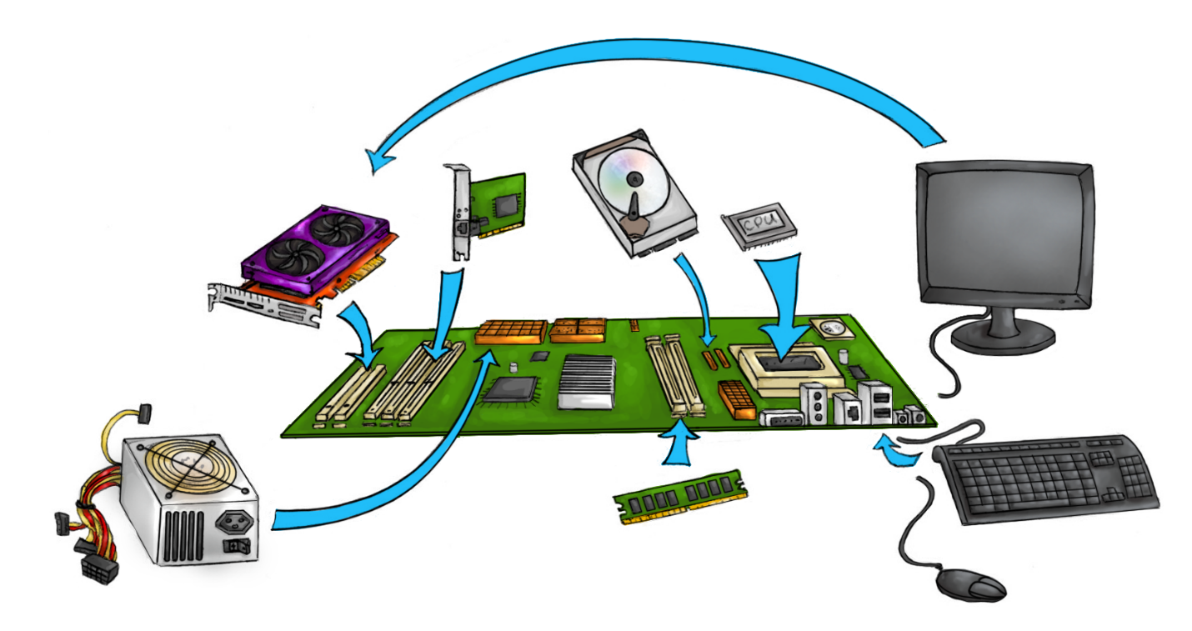**Activity II: Identify Computer Parts**

Work with your facilitator to identify all parts of the computer system.

**Activity III: Data flows from part to part**

Please fill in the steps on how picture data moves through the computer for display:

Read picture file from _________

Transfer picture data to _________

Write pixels to video memory for display.

Complete the steps for how to display a character that is input from the keyboard:

Read the input from the keyboard

**Activity IV: Put together the Raspberry Pi computer**

Work with your facilitator to put together the Raspberry Pi computer. Connect the power at the end.

Here is a picture of an old Raspberry Pi:

How do you think computers work?

Based on this diagram, can you identify all of the components of your new Raspberry Pi? What has changed since then?